An **equi join** in SQL is a type of inner join where the tables are joined based on a condition of equality between columns. Here's an example using the Student and Course tables.

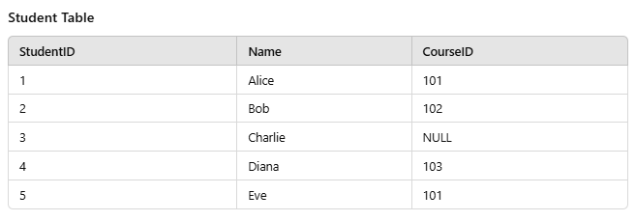

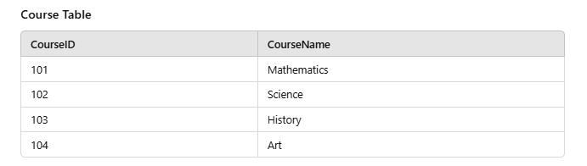

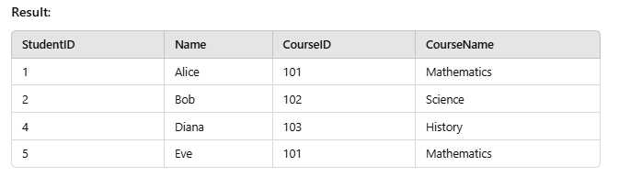

Query1

SELECT Student.StudentID, Student.Name, urse.CourseID,

Course.CourseName FROM Student JOIN Course

ON Student.CourseID = Course.CourseID;

Query2 (with condition)

SELECT Student.StudentID, Student.Name,

Course.CourseID, Course.CourseNameFROM

Student JOIN Course ON Student.CourseID = Course.CourseID WHERE Course.CourseName = Mathematics';